All the things we can do with one pencil. Exploring the capabilities of the medium
-Taking a line for a walk -Mark making
-Mazes
-Continuous lines -Blind drawing -Left hand
-Scribble and rub
-Using masking tape to cover parts of a paper, scribble the whole page and later peel of the masking tape. You left with a fragmented drawing and you could use the marking tape for another artwork.
-Accidental drawing
-Different pressure
-Exploring different emotions
-Patterns
-Cut a line and convert it into a 3 D sculpture
Sketch book for the children so kids could practice.
Artists
-Cy Twombly
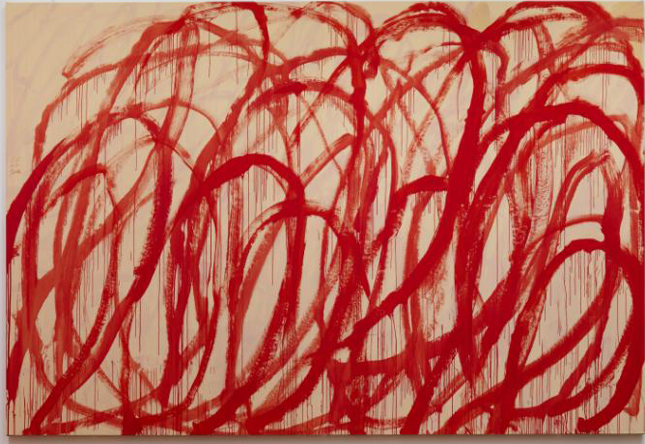

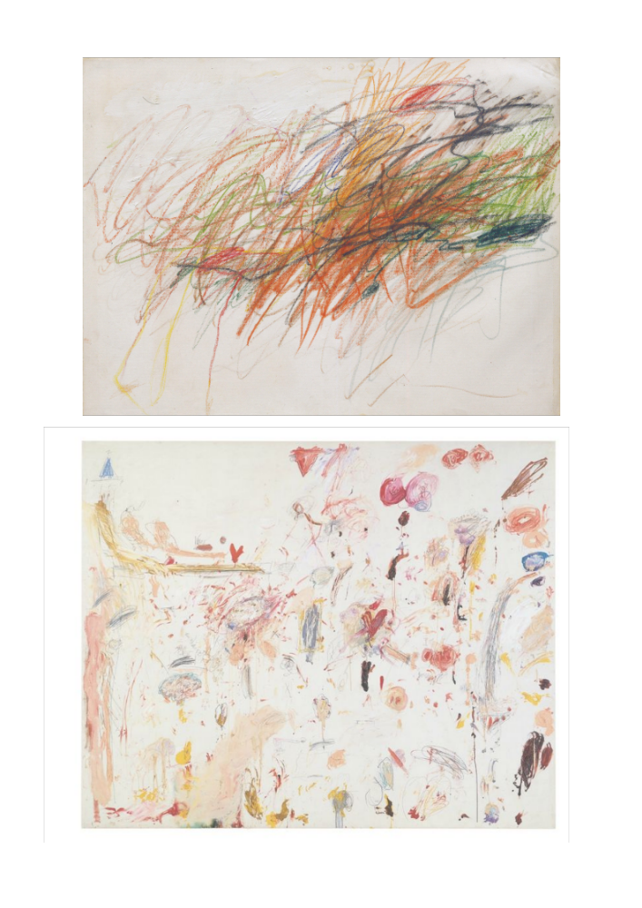

-Antoni Tàpies
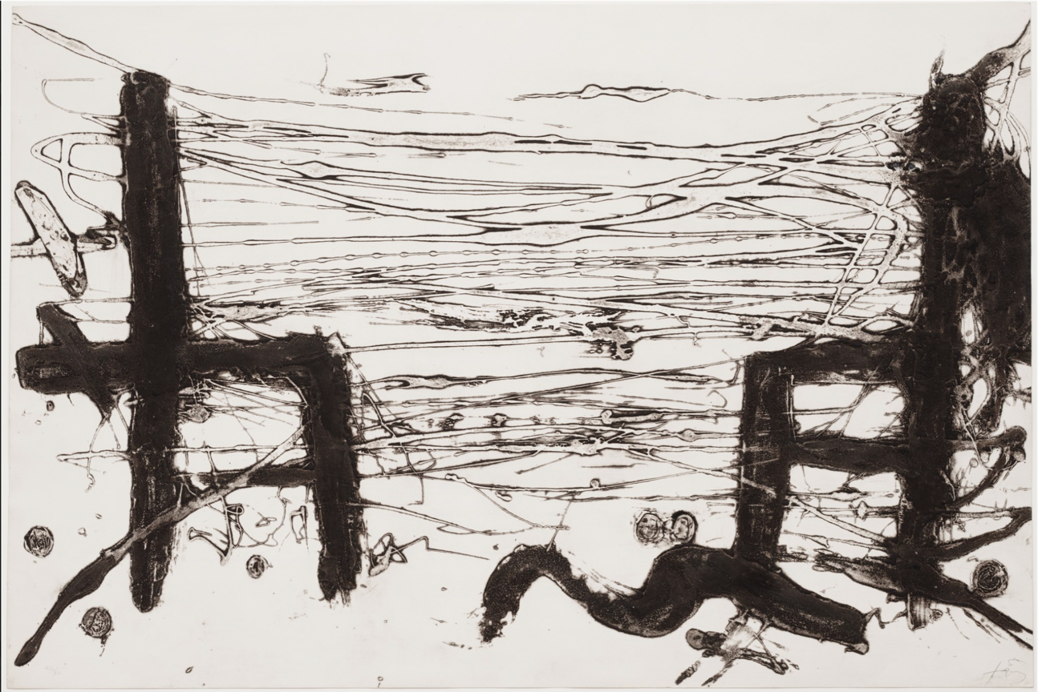

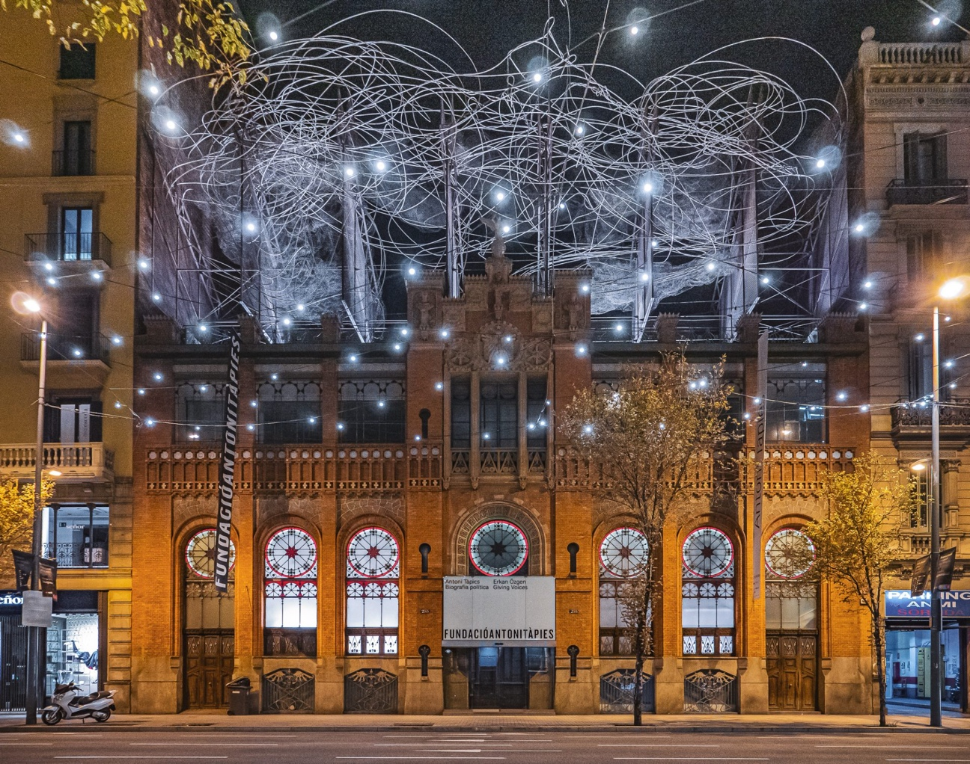

-Anselm Kiefer

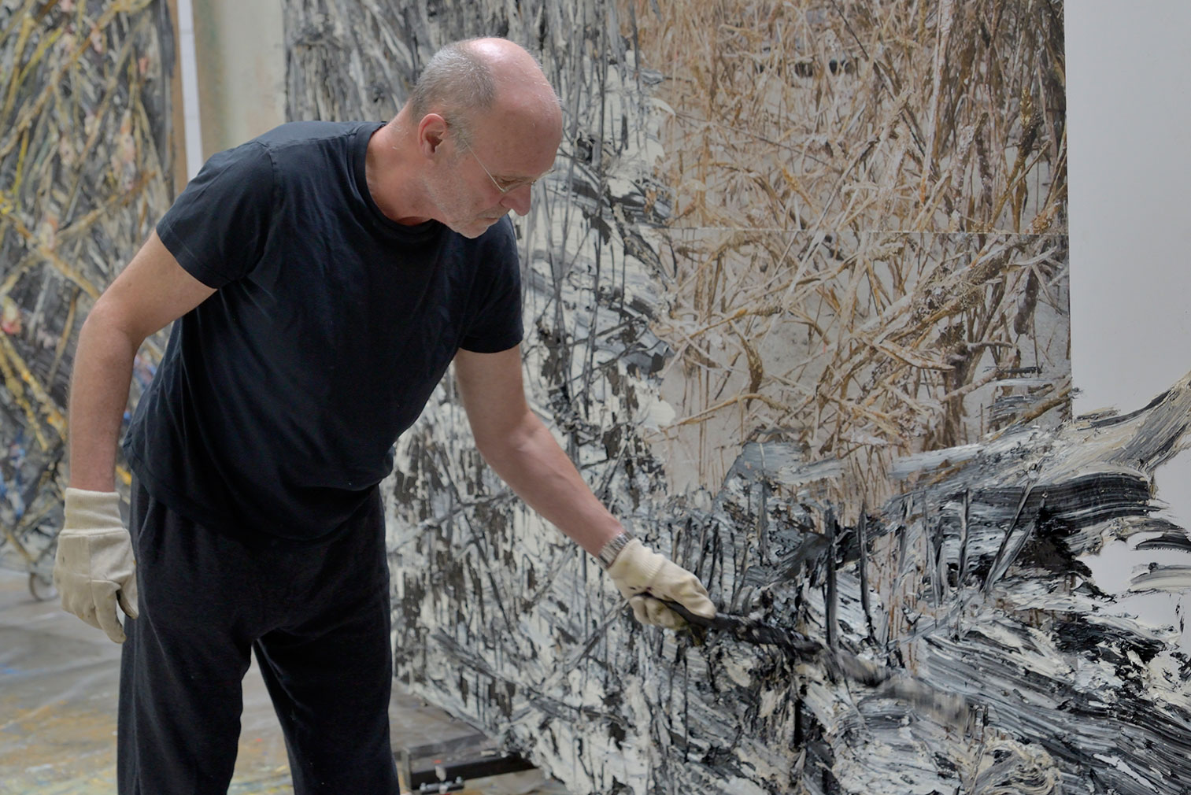

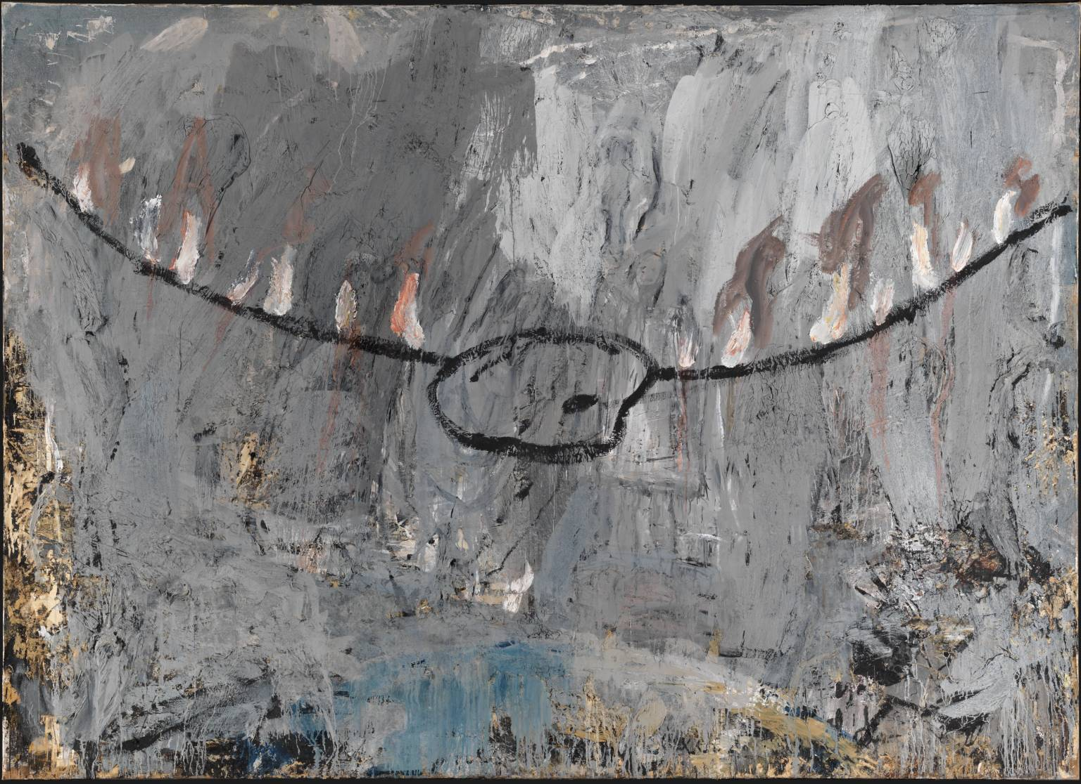

-Alberto Giacometti
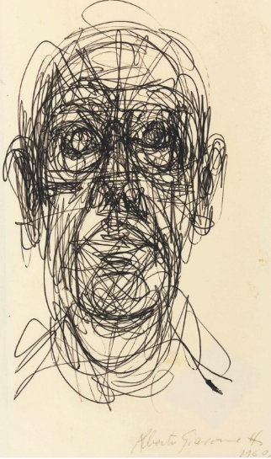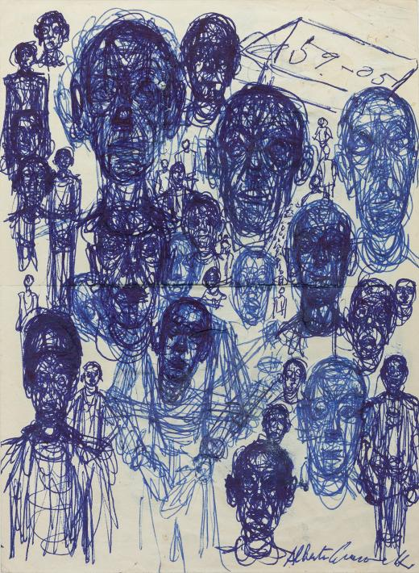

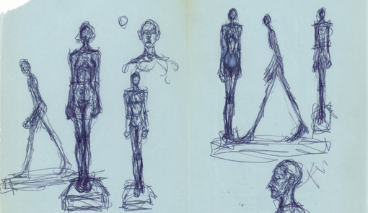

-Lucio Fontana
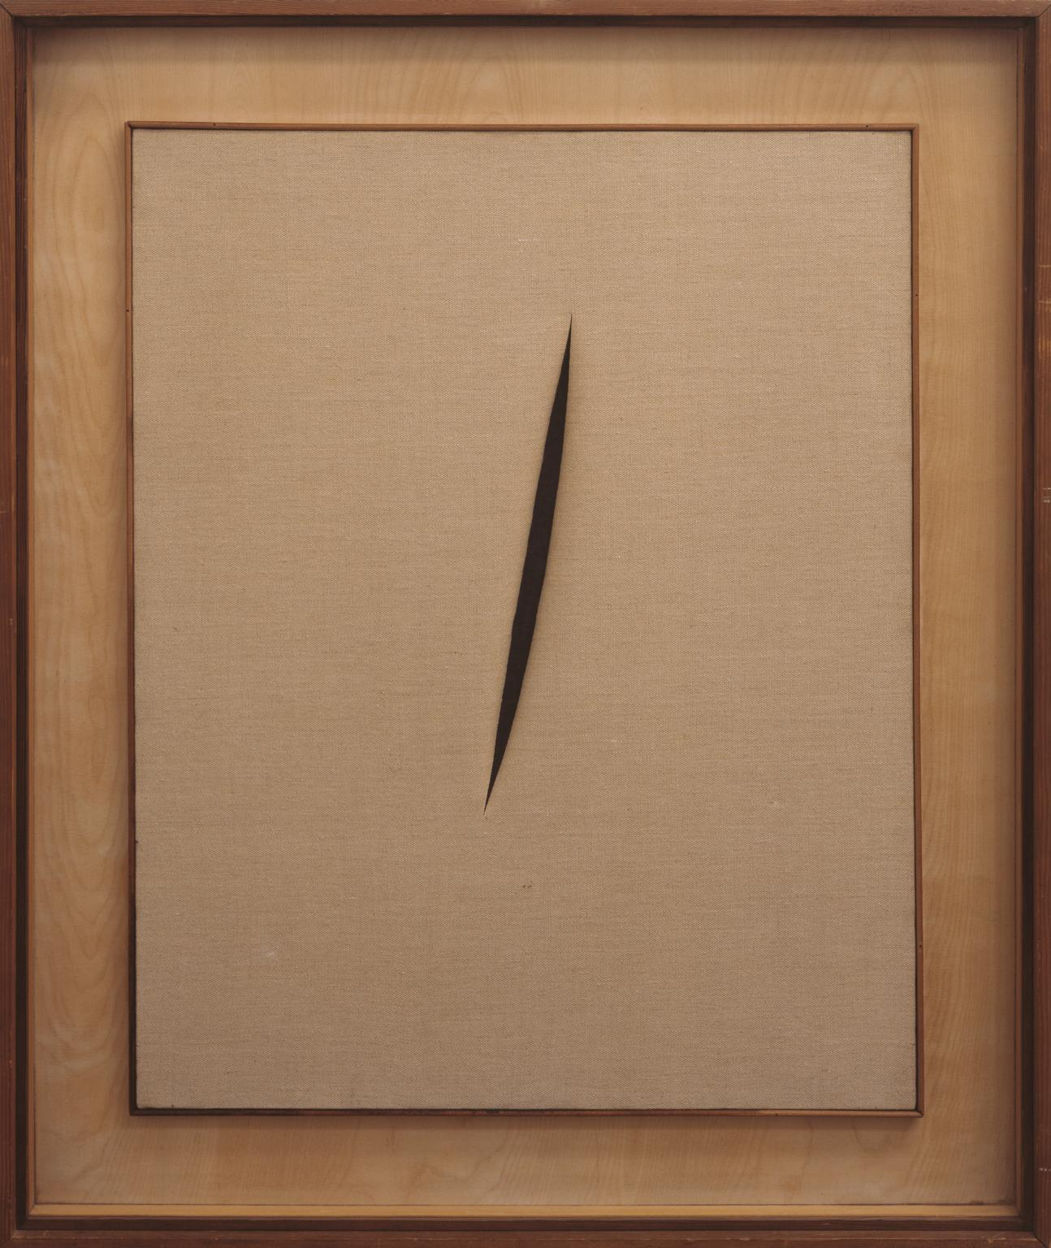

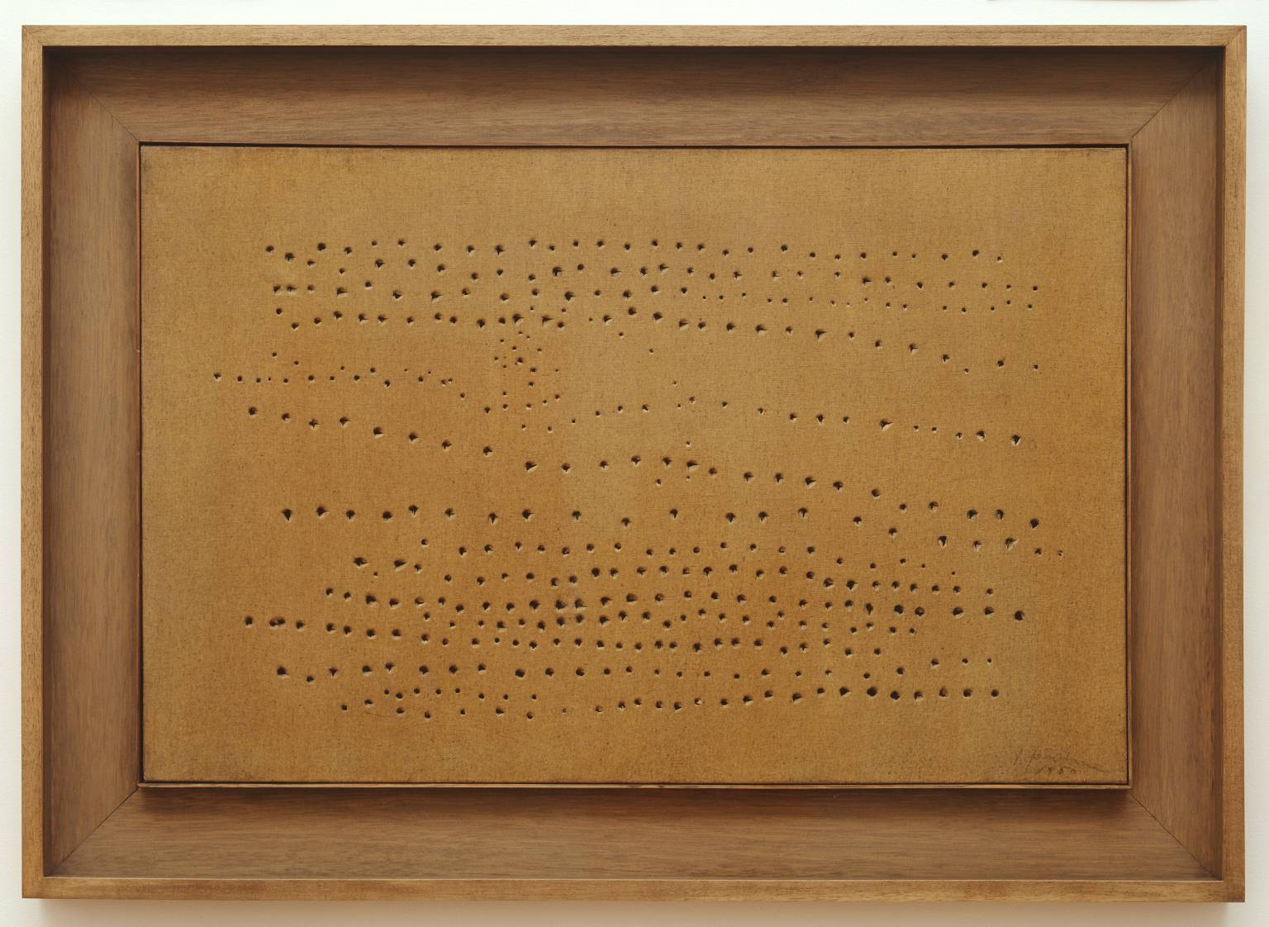
-Julie Mehretu
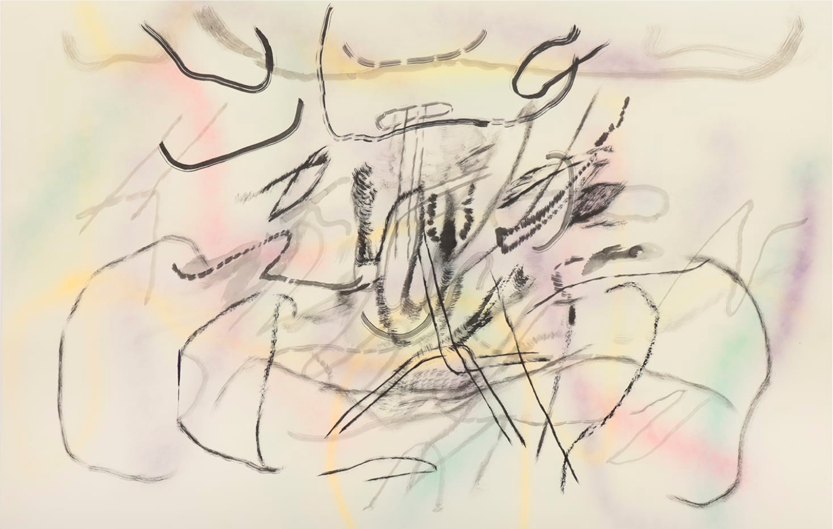

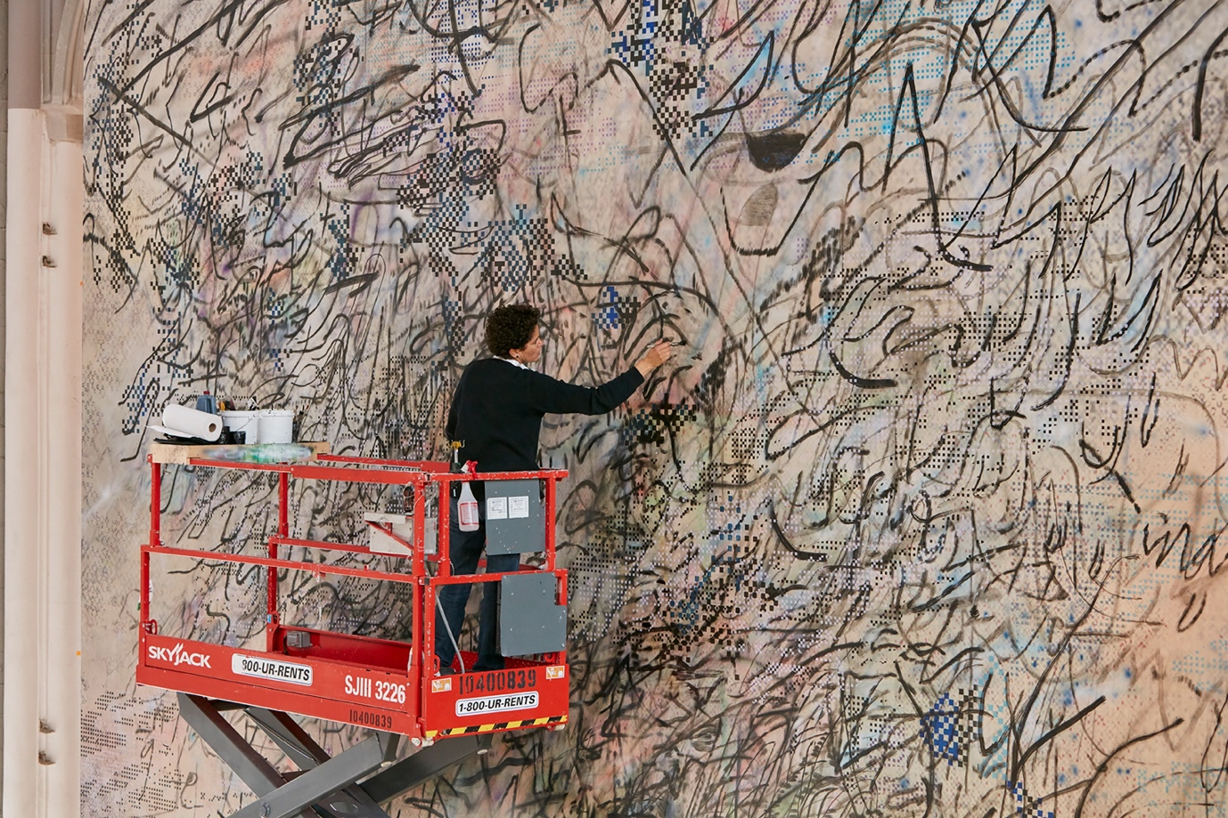

-Richard Long

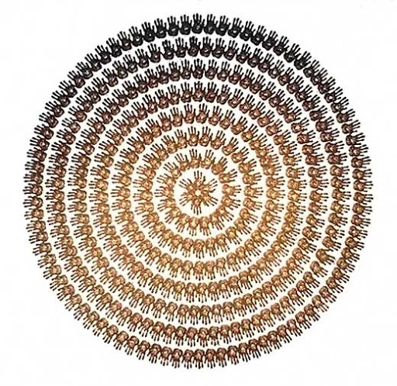
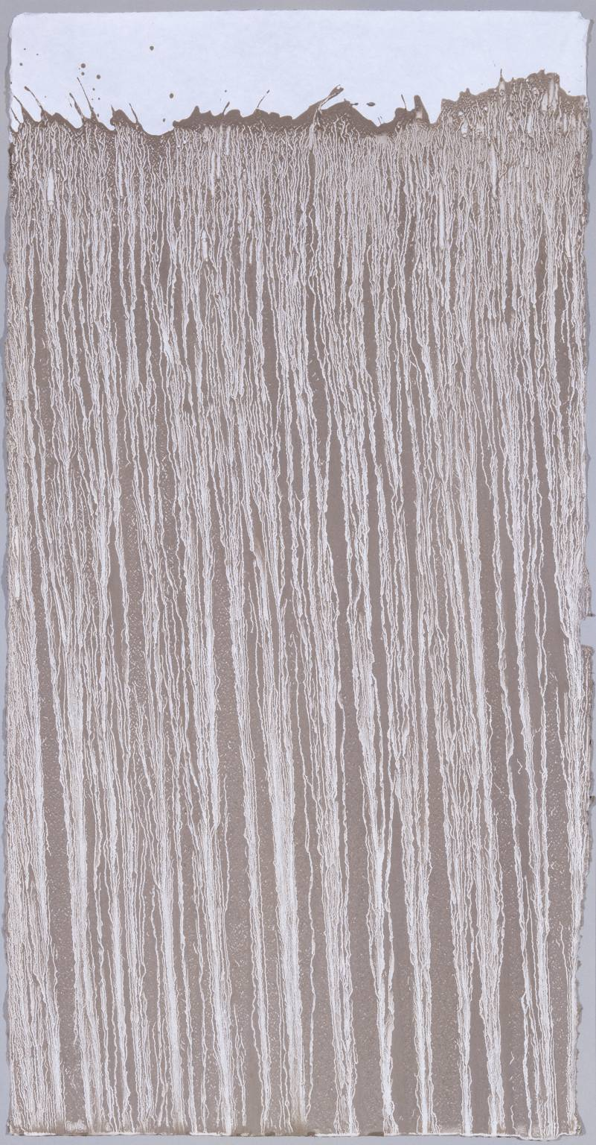

-Jean Dubuffet

